Lecturer: Dr Oisín Cawley

Continuous Assessment 1
Value: 20% of overall mark
Due Date: Fri 4th Dec 2025

Gravity Shift Connect 4

You must produce a digital version of the game Connect 4 but with a twist. The aim of the game is to simply get 4 pieces in a row! The rules are simple enough .

The Game
It is a two-player, turn-based, perfect-information, zero-sum game. The board is a 6 Row x 7 Column grid to start. The usual Connect 4 rules apply. However, after every 4 moves, a change in the Earth’s gravity rotates the board 90 degrees clockwise and consequently all the pieces fall down towards the new bottom of the board.
For example:
After 4 moves the board might look like this:
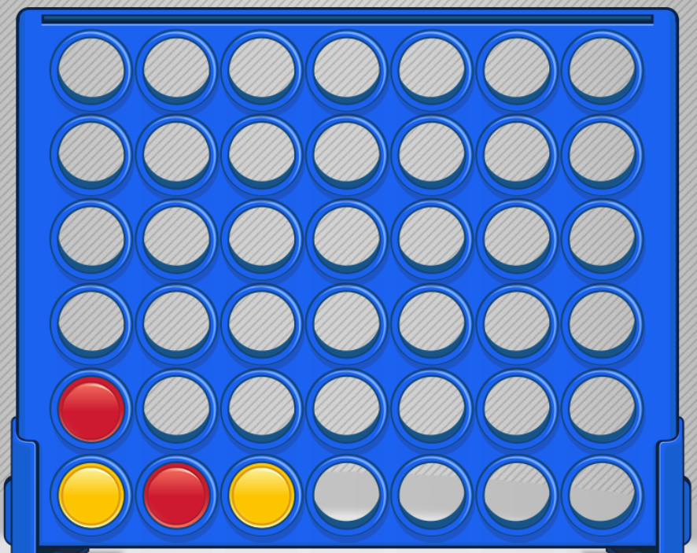

Following the gravity shift, the board will look like this:

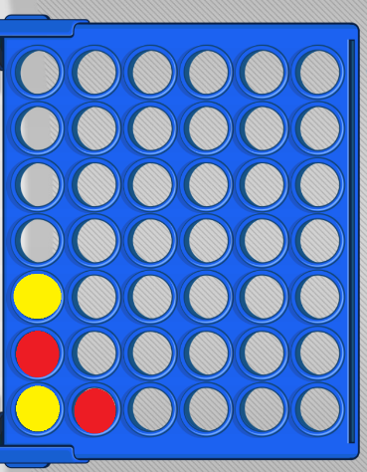

Pieces continue to be put in from the top row which now has only 6 columns.
To do:
You are also to implement an AI that can play the game against a human. The user should be able to choose to play against an AI that implements the Minimax algorithm or an AI that implements the Monte Carlo Tree Search algorithm. You therefore need to implement both algorithms.

The project has incremental phases and you submit a zipped project to Blackboard following each Phase.

Project Details
Game to be produced in C++ and SFML or Raylib and documented using Doxygen.


The use of AI is optional, however anything you hand up you must know and understand 100%.

The project is split in to 4 phases and each phase is submitted to Blackboard and graded as below. You will need to be continuously active on the project, and this is to be demonstrated in the lab each Friday.

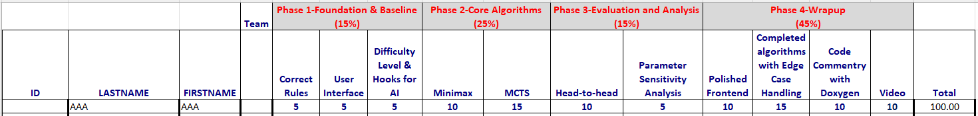

Phase 1 – Core game and user interface demonstrating rules understanding (Nov 13th)
- Get the core project up and running with the appropriate code structure ready for dropping in the AI algorithms
Phase 2 – Core Minimax and MCTS implementations (Nov 20th)
- Correct implementations of the two algorithms
- Should include specific considerations for user-chosen difficulty level
Phase 3 – Evaluation, Analysis & Tuning (Nov 27th)
- Demonstrate some empirical analysis. For example: a structured tournament with MCTS vs Minimax, MCTS vs MCTS (different iteration counts), advanced minimax-vs-minimax baseline etc.
Phase 4 – Robustness, Integration & video (Dec 4th)
- Deliver something usable and defensible. Integration with the existing GUI, edge-case handling, and a clear demo and walk through of the AI algorithms.

This is obviously based on an existing game but with some different rules. There are lots of implementations of 4 in a row online and so AI is going to be able to do a lot of this.
But remember there is the empirical study, video and code commentary expected that you need to do yourself. The video should be a max 5-minute video explaining your code in detail but concentrating on the AI implementations and how they work with the game. Make sure the code is large enough for me to see what you are referring to in the video.

Ensure that any specific technical requirements of the game are clearly highlighted. If you use external libraries, for example Thor, make sure they are part of your project. I don’t want to have to go looking for and installing stuff.
The best way to provide the above information is to submit an accompanying Readme.txt file with any points you think are important.

Team or Individual
This is a team (of 2) project. You may do it on your own if you prefer. You must email me the names of the people in your team asap. Project submission must include the % of each component that each student contributed to. However, you might simply agree the effort was 50/50 therefore you would both get equal marks. Sometimes this is not the case, and so the team must therefore agree on these %s when submitting (the total must add up to 100).

